

Department of Computer Engineering & Applications

**Institute of Engineering & Technology**



**Project Report on Floracity**

Submitted by:

Sakshi garg(A/191500699)

Tanya Agrawal (A / 191500849)

Vartika Saxena(A/ 191500896)

##### 



**Full stack project (2021-2022)**

**Synopsis Report**



**Team Members**

* *Sakshi Garg (University roll no – 191500699)*
* *Tanya Agrawal (University roll no – 191500849)*
* *Vartika Saxena (University roll no – 191500896)*

**Supervised By -:**

***Mr. Pankaj Kapoor***

*(Technical Trainer)*

*(Department of Computer Science Engineering & Applications)*

**Project Title – FloraCity**

**Introduction-**

E-commerce is fast gaining ground as an accepted and used business paradigm. More and more business houses are implementing web sites providing functionality for performing commercial transactions over the web. It is reasonable to say that the process of shopping on the web is becoming commonplace.

FloraCity is basically an E-Commerce store where user can search about any type of flora specie and can purchase it at reasonable rates.

**Objective-**

So after keeping all these factors in mind, the main objective of this project is to develop a general-purpose e-commerce store where Plants and seeds can be bought from the comfort of home through the Internet.

**Working Methodology-**

* The purpose behind to make this project is to provide a platform where any one can buy whatever the Plant they want to buy.
* As we know there are many e-commerce sites available to provide such type of facilities but our main motive willbe to provide a brief knowledge about the product as well as and to provide a good quality product to our Customers.
* There will be sub-sections as well as that will define various types of categories of flora species and user can directly navigate to his/her preference.

**Software Specification**

* Technology Implemented: Front-End Technologies
* Language Used: HTML, CSS, JavaScript, Bootstrap,jQuery
* Development Environment: Visual Studio code
* Web Browser: Chrome

**Hardware Requirements**

* Processor: intel i3
* Operating System: Windows 10
* RAM: 4+GB
* Hard disk: 64 GB

**Team contribution-**

* In this project we are working in a team of 3 persons.
* Sakshi will work on Home page, register and login form.
* Tanya will work on home page .
* Vartika will work on categories visualization.
* Product page will made by sakshi.
* Sakshi ,Vartika and Tanya will work on Categories.

**Limitations of The System Proposed-**

* Internet connection is required while accessing the website.
* User may find difficulty in searching for the required data.
* At some places content may not be provided.
* As we are working on front end part only, so user may find difficulty in accessing data from server.

**Online GIT repository-**

<https://github.com/TanyaMittal31/FloraCity>

https://tanyamittal31.github.io/FloraCity/

**Conclusion –**

Focusing on the current requirements of a healthy life and to make the life easier of our customers we are going to work on this great and handy ecommerce store.

**References:**

* [www.beta-labs.in](http://www.beta-labs.in)
* <https://www.w3schools.com>
* <https://stackoverflow.com>
* Wikipedia
* <https://github.com/>
* <https://www.ugaoo.com/?gclid=CjwKCAjwhaaKBhBcEiwA8acsHH_Ira3L5iI03G3EmEVyJernK2423e_USr5rj-mCT1Hqtg08hx0ZRhoC_3YQAvD_BwE>
* Naturelive
* YouTube

https://lh4.googleusercontent.com/-7NPHzoVzwsdIcAuD3KPZKaj8-64d_JjpqsNqu6Vt3qI1RFora_dhTFfT66AW8GERlDInYDl2cezHdLJyGQJpbsofE-9pnS8dQdIFEeGNHwvXg6onJ4OKlXd1ptnuTiZT580OlTk





29/4/20

18/6/20

7/8/20

26/9/20

15/11/20

4/1/21

Goal Identification

Synopsis Submission

Planning

Analysis

Design

Implementation

###### *Gantt Chart*



# ACKNOWLEDGEMENT

The project work in this report is an outcome of continuous work over a period and drew intellectual support from various sources. We would like to articulate our profound gratitude to all those people who extended their wholehearted co- operation and have helped us in completing this project successfully.

We are thankful to our mentor **Pankaj Kapoor** for teaching and assisting us in making the project successful. We would also like to thank other fellow mates for guiding and encouraging us throughout the duration of the project.

We would also like to thank the teaching staff for their constant encouragement, support and guidance which helped us in successfully completing the project work.

**Tanya Agrawal**

**Sakshi garg**

**Vartika Saxena**



# ABSTRACT

Recently the e-commerce platform is playing an important role in some areas; its activities are a subset of e-business activities. The aim of this paper is to build and develop a reliable website based on the e-commerce theories, developing effective well designed web pages. This website will sell computer products include (hardware and software). For implement the selling online website, it needs to use current technologies to achieve this goal. As a first stage, it should setting up online ecommerce store with easy-to-use. Then improve the customer experience, and lastly implement the Direct Online Sale between business to consumer by implement electronic payment methods. All these techniques should be based on deliberated plan according to strategy of electronic commerce with implement the current technology to ensure a good revenue to the company.



# Table of Contents

Certificates Acknowledgment Abstract

**Chapter 1: Introduction**

* 1. Overview
  2. Why we choose this project
  3. Motivation
  4. Objective
  5. Future Scope

##### Chapter 2: System Design and Methodology

* 1. System Module
     1. User in this module
     2. Admin in this module
  2. Methodology
  3. Implementation Requirements
     1. Hardware Requirements
     2. Software Requirements
  4. Maintenance

##### Chapter 3: Tools and Technology

* 1. Technologies used



* + 1. HTML
    2. CSS
    3. Javascript
    4. Bootstrap

##### Chapter 4: Result and Conclusion

References



**CHAPTER - 1**

# INTRODUCTION

### Overview

The ‘Online E-commerce Web application’ Services department strives to provide solutions to develop and transfer easy and efficient way in the digital age and to help reduces the human pressure and time. To help support shop collections, the digital initiatives, and external partner institution digital projects, It provide services that include the digitization of analog objects, metadata management, digital preservation, and discovery and access of digital collections. “Shop Management System” is a web application written for all operating systems, designed to help users maintain and organize shop virtually. This software is easy to use for both beginners and advanced users. It features a familiar and well thought-out, an attractive user interface, combined with strong searching Insertion and reporting capabilities. The reportgeneration facility of shop system helps to get a good idea of which are the various items brought by the members, makes users possible to get the product easily.The ‘Online E-commerce Web application’ Services department strives to provide solutions todevelop and transfer easy and efficient way in the digital age and to help reduces the human pressure and time. To help support shop collections, the digital initiatives, and external partner institution digital projects, It provides services that includethe digitization of analog objects, metadata management, digital preservation, and discovery and access of digital collections. “Shop Management System” is a web application written for all operating systems, designed to help users maintain and organize shop virtually. This software is easy to use for both beginners and advanced users. It features a familiar and well thought-out, an attractive user interface, combined with strong searching Insertion and reporting capabilities. The report generation facility of shop system helps to get a good idea of which are the various items brought by the members, makes users possible to get the product easily

### Why we choose this project

E-commerce is fast gaining ground as an accepted and used business paradigm. More and more business houses are implementing web sites providing functionality for performing commercial transactions over the web. It is reasonable to say that the process of shopping on the web is becoming common place. The objective of this project floracity is to develop a general-purpose e-commerce store where any type of flowers bouquet can be bought from the comfort of home through the Internet. However, for implementation purposes, this paper will deal with an online ecommerce store. An online store is a virtual store on the Internet where customers can browse the catalog and select products of interest. The selected items may be collected in a shopping cart. At checkout time, the items in the shopping cart will be presented as an order. At that time, more information will be needed to complete the transaction.

Usually, the customer will be asked to fill or select a billing address, a shipping address, a shipping option, and payment information such as a credit card number. An email notification is sent to the customer as soon as the order is placed.



Project Planning

Project planning is part of project management, which relates to the use of schedules such as Gantt charts to plan and subsequently report progress within the project environment. Initially, the project scope is defined and the appropriate methods for completing the project are determined. Following this step, the durations for the various tasks necessary to complete the work are listed and grouped into a work breakdown structure. The logical dependencies between tasks are defined using an activity network diagram that enables identification of the critical path. Float or slack time in the schedule can be calculated using project management software. Then the necessary resources can be estimated and costs for each activity can be allocated to each resource, giving the total project cost. At this stage, the project plan may be optimized to achieve the appropriate balance between resource usage and project duration to comply with the project objectives. Once established and agreed, the plan becomes what is known as the baseline. Progress will be measured against the baseline throughout the life of the project

### Future Scope

### The project has a very vast scope in future. The project can be implemented on intranet in future.

### Project can be updated in near future as and when requirement for the same arises, as it is very

### flexible in terms of expansion. With the proposed software of database Space Manager ready and

### fully functional the client is now able to manage and hence run the entire work in a much better,

### accurate and error free manner.

### The following are the future scope for the project.

### 1. Should be added payment gateway

### 2. Can be added inventory management system

### 3. Can be added multiple branches

### 4. Can be added multilingual to this site

### 5. And many features can be added this project to make it more robust

### Objective

### The project is about to handle all the information of the shop regarding members. Also it manages resources which were managed and handled by manpower previously. The main purpose of the project is to integrate distinct sections of the shop into consistent manner so that complex functions can be handled smoothly. The project aims at the following matters.

•Automation of product manipulation.

•Buying products.

•To manage information of different types of items.

•Consistently update information of all the item.

•Managing security by providing authorized email & password. Manages database efficiently.



**CHAPTER - 2**

**SYSTEM MODULE AND METHODOLOGY**

This chapter discusses the architecture, various hardware and software requirements and challenges of the project.

### System Module

The modules involved in this project are

* + 1. User
    2. Admin

##### User in this module:

* + - * User can sign up
      * User can login
      * User can add information
      * User can add comments
      * User can select any categories

##### Admin in this module:

* + - * Admin can see all pages
      * Admin can maintain all records of user
      * Admin provide all information related to any topic
      * Admin can delete/update/select users

### Methodology

* The planning stage
* The analysis stage is the most critical stage, and concerns the content of information and the attractiveness of web application design. It analyses and examines the requirements to produce a complete website (Front-End) throughout the development life cycle.This is to ensure that the web- based information is feasible to be developed.
* The design stage provides a ‘skeleton’ to the web-based information where it describes how such a website is to be designed. All necessary design specifications are developed including interface design.
* The implementation stage involves constructing interfaces and implementing codes according to design specifications. The actual program codes that are written may conform to the web standards Testing the web-based information systems for quality assurance is also required and must take into consideration the nature of the web.
* The maintenance stage ensures the content of the web-based information systems is dynamically updated and made continuously reliable by reviewing and maintaining the systems.



### Implementation Requirements

In this section we will discuss about the various hardware and software requirements

* + 1. **Hardware Requirements:**
       - Processor Pentium||||630MHz
       - RAM. 128 Mbhn
       - Hard Disk. 20GB
       - Monitor. 15'' color monitor
* Keyboard 122 keys

###### Software Requirements:

* + - * VSCodeUserSetup-x64-1.45.1
      * Web browser

### Maintenance

The website involves following Maintenance processes

* Manage Post
* Manage Topics
* Manage User



**CHAPTER-3**

## TOOLS AND TECHNOLOGY

* 1. **Technologies used :** HTML, CSS, Javascript, Bootstrap

##### HTML

HTML is the standard markup language for creating Web pages.

**What is HTML?**

* + - 1. HTML stands for Hyper Text Markup Language
      2. HTML is the standard markup language for creating Web pages
      3. HTML describes the structure of a Web page
      4. HTML consists of a series of elements
      5. HTML elements tell the browser how to display the content
      6. HTML elements label pieces of content such as "this is a heading", "this is a paragraph", "this is a link", etc.

##### HTML Element

An HTML element is defined by a start tag, some content, and an end tag:

<tagname>Content goes here...</tagname>

The HTML element is everything from the start tag to the end tag:

<h1>My First Heading</h1>



<p>My first paragraph.</p>

##### HTML Documents

All HTML documents must start with a document type declaration: <!DOCTYPE html>.

The HTML document itself begins with <html> and ends with </html>.

The visible part of the HTML document is between <body> and </body>.

* + 1. **CSS**

##### What is CSS?

* CSS stands for Cascading Style Sheets
* CSS describes how HTML elements are to be displayed on screen, paper, or in other media
* CSS saves a lot of work. It can control the layout of multiple web pages all at once
* External stylesheets are stored in CSS files

#### CSS Syntax

A CSS rule-set consists of a selector and a declaration block:

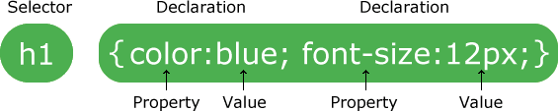



* The selector points to the HTML element you want to style.
* The declaration block contains one or more declarations separated by semicolons.
* Each declaration includes a CSS property name and a value, separated by a colon.
* Multiple CSS declarations are separated with semicolons, and declaration blocks are surrounded by curly braces.

#### CSS Selectors

CSS selectors are used to "find" (or select) the HTML elements you want to style. We can divide CSS selectors into five categories:

* Simple selectors (select elements based on name, id, class)
* [Combinator selectors](https://www.w3schools.com/css/css_combinators.asp) (select elements based on a specific relationship between them)
* [Pseudo-class selectors](https://www.w3schools.com/css/css_pseudo_classes.asp) (select elements based on a certain state)
* [Pseudo-elements selectors](https://www.w3schools.com/css/css_pseudo_elements.asp) (select and style a part of an element)
* [Attribute selectors](https://www.w3schools.com/css/css_attribute_selectors.asp) (select elements based on an attribute or attribute value)

#### Javascript

* JavaScript is the world's most popular programming language.
* JavaScript is the programming language of the Web.
* JavaScript is easy to learn.

##### JavaScript Can Change HTML Content

One of many JavaScript HTML methods is getElementById().

The example below "finds" an HTML element (with id="demo"), and changes the element content (innerHTML) to "Hello JavaScript":

Example



document.getElementById("demo").innerHTML = "Hello JavaScript";

##### JavaScript Values

The JavaScript syntax defines two types of values:

* Fixed values
* Variable values

Fixed values are called Literals. Variable values are called Variables.

##### JavaScript Literals

The two most important syntax rules for fixed values are:

1. Numbers are written with or without decimals
2. Strings are text, written within double or single quotes

##### JavaScript Variables

In a programming language, variables are used to store data values.

JavaScript uses the var keyword to declare variables. An equal sign is used to assign values to variables.

##### Bootstrap

Bootstrap is the most popular HTML, CSS, and JavaScript framework for developing responsive, mobile- first websites.

##### What is Bootstrap?



* Bootstrap is a free front-end framework for faster and easier web development
* Bootstrap includes HTML and CSS based design templates for typography, forms, buttons, tables, navigation, modals, image carousels and many other, as well as optional JavaScript plugins
* Bootstrap also gives you the ability to easily create responsive designs

##### Why Use Bootstrap?

Advantages of Bootstrap:

* Easy to use: Anybody with just basic knowledge of HTML and CSS can start using Bootstrap
* Responsive features: Bootstrap's responsive CSS adjusts to phones, tablets, and desktops
* Mobile-first approach: In Bootstrap 3, mobile-first styles are part of the core framework
* Browser compatibility: Bootstrap is compatible with all modern browsers (Chrome, Firefox, Internet Explorer, Edge, Safari, and Opera)

##### Bootstrap Grid System

* Bootstrap's grid system allows up to 12 columns across the page.
* Bootstrap's grid system is responsive, and the columns will re-arrange automatically depending on the screen size.







##### Grid Classes

The Bootstrap grid system has four classes:

* xs (for phones - screens less than 768px wide)
* sm (for tablets - screens equal to or greater than 768px wide)
* md (for small laptops - screens equal to or greater than 992px wide)
* lg (for laptops and desktops - screens equal to or greater than 1200px wide)

##### Basic Structure of a Bootstrap Grid

The following is a basic structure of a Bootstrap grid:

<div class="row">

<div class="col-*-*"></div>

<div class="col-*-*"></div>

</div>



<div class="row">

<div class="col-*-*"></div>

<div class="col-*-*"></div>

<div class="col-*-*"></div>

</div>

<div class="row">

</div>



**CHAPTER-4**

## RESULT AND CONCLUSION

## Home Page:

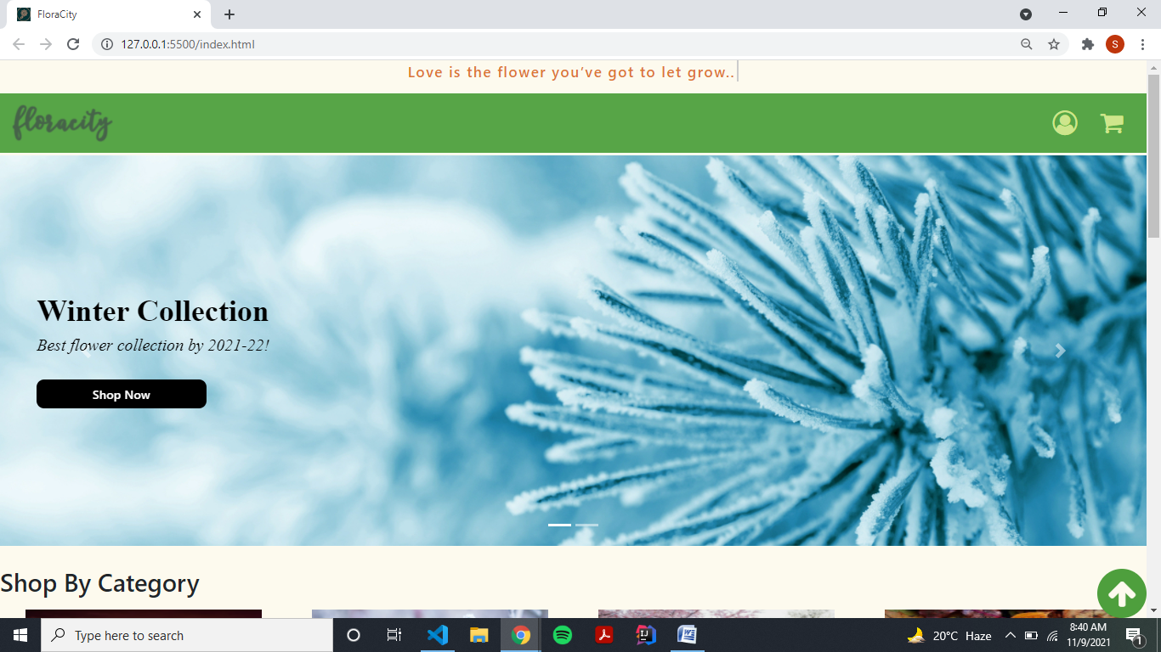

**Shop page :**

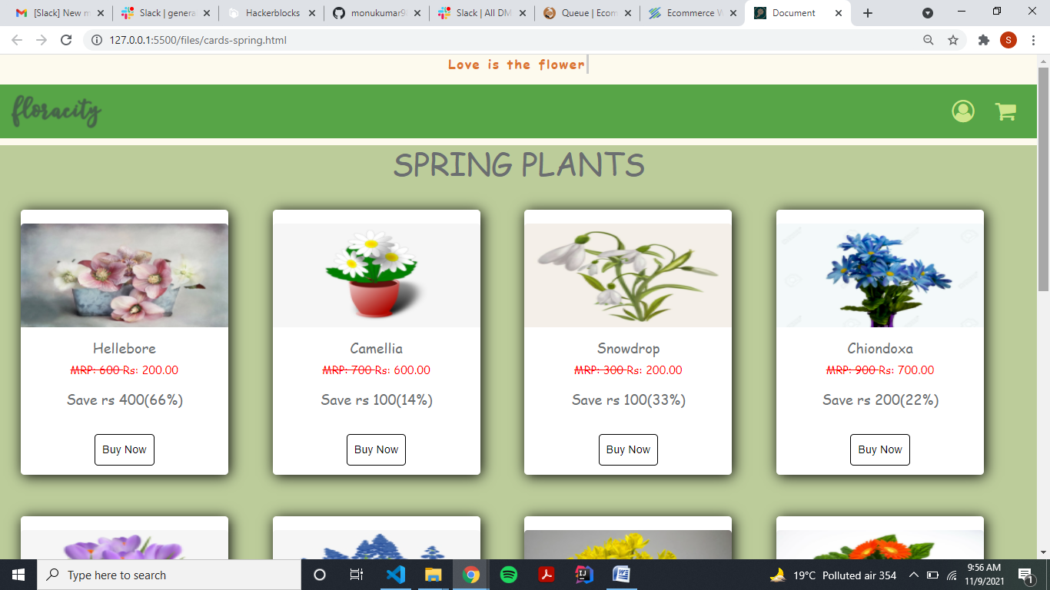

**Single Product page**

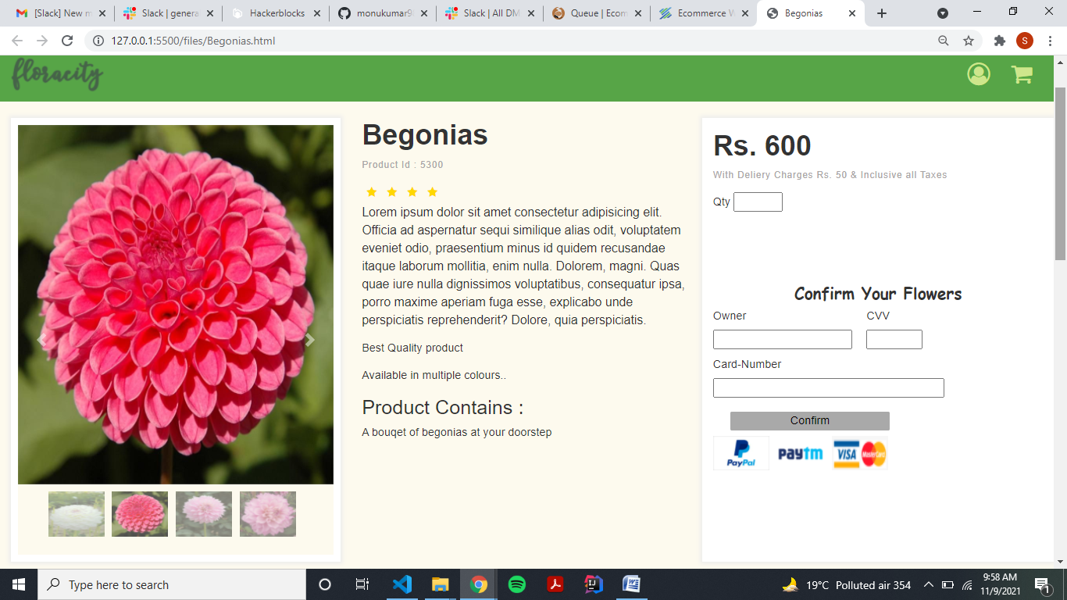

**Cart Page**

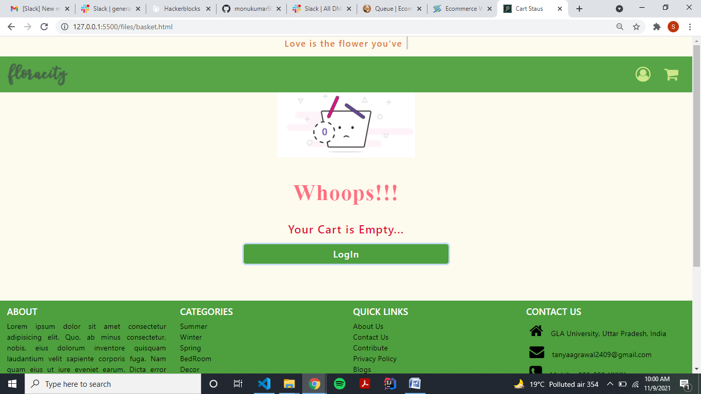

**User Login page**

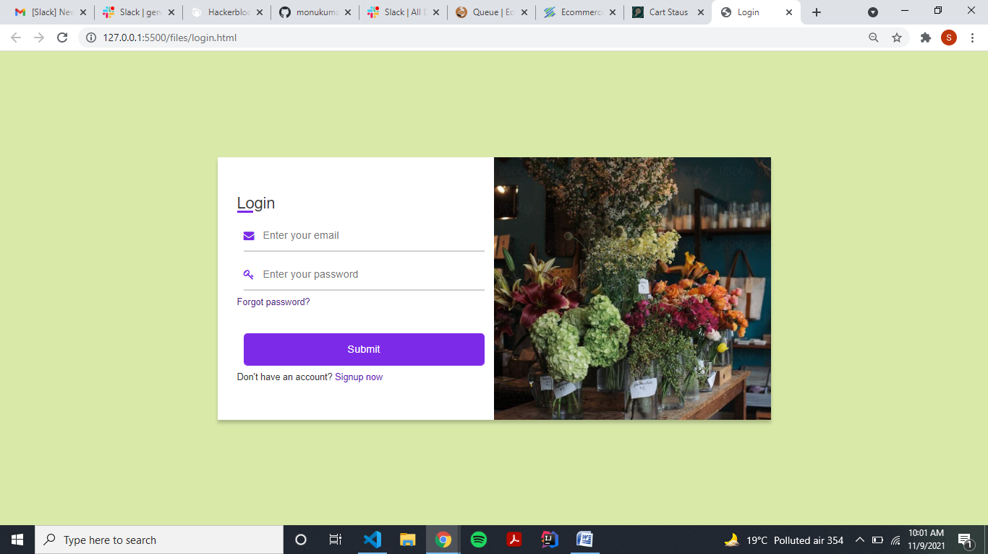

**User Registration page**

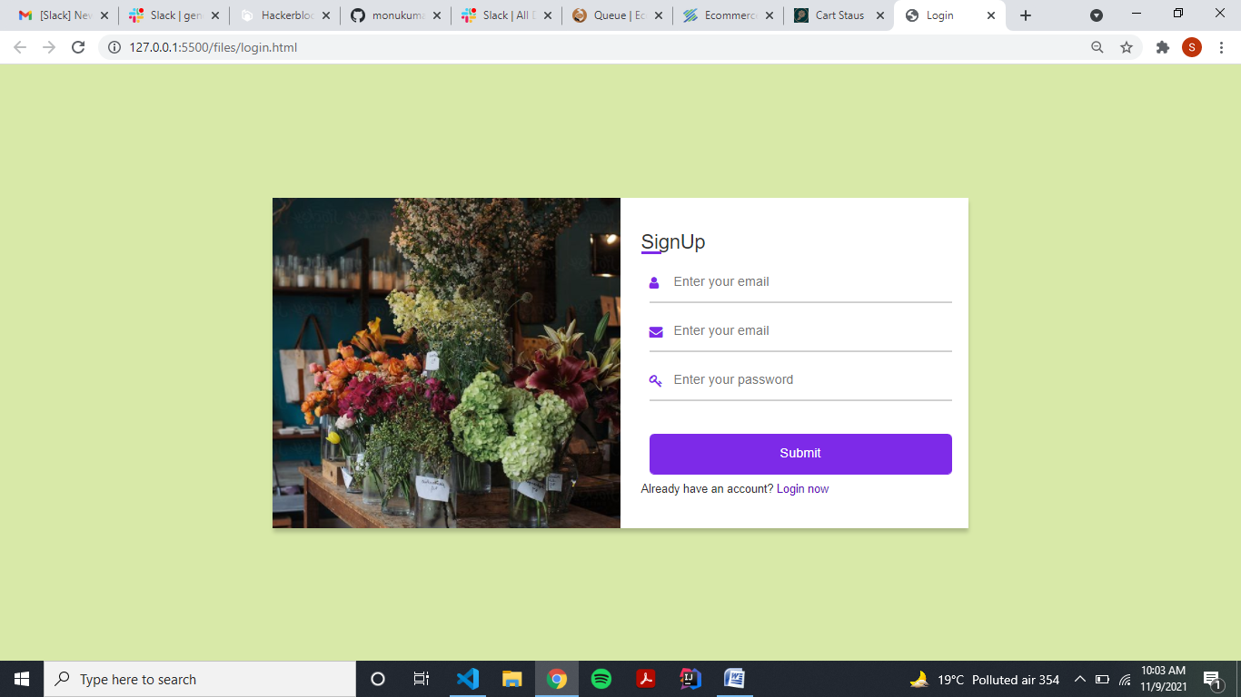

**Categories :**

**\**

**Summer**

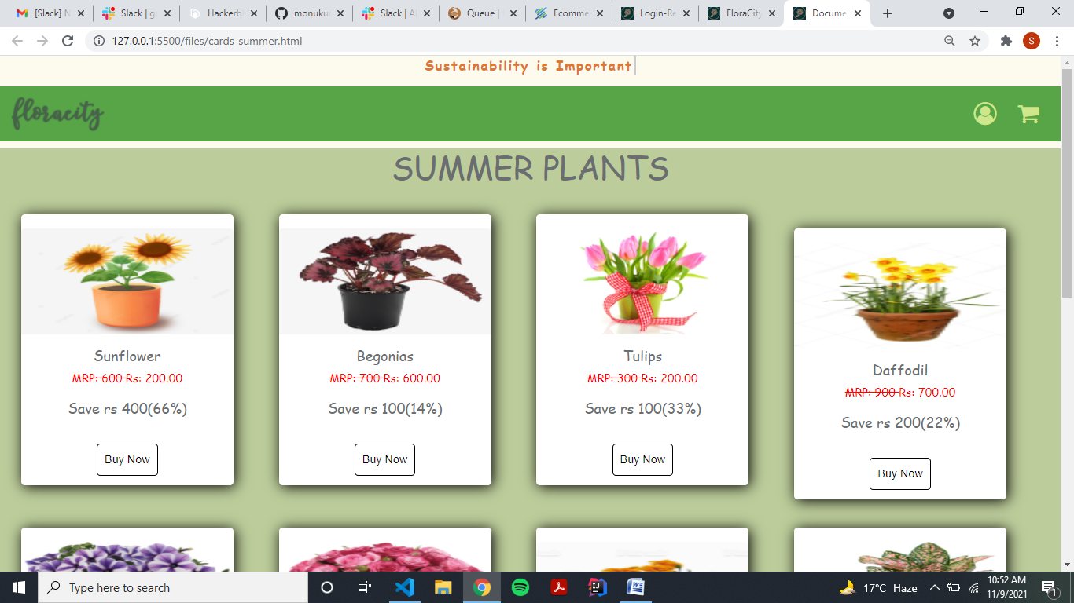

**Winter**

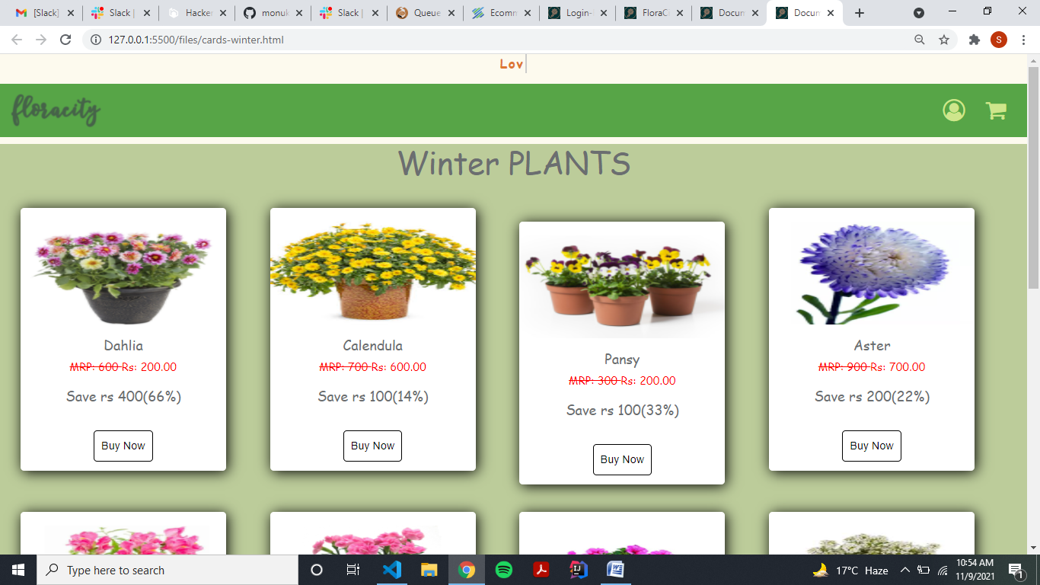

**Spring**

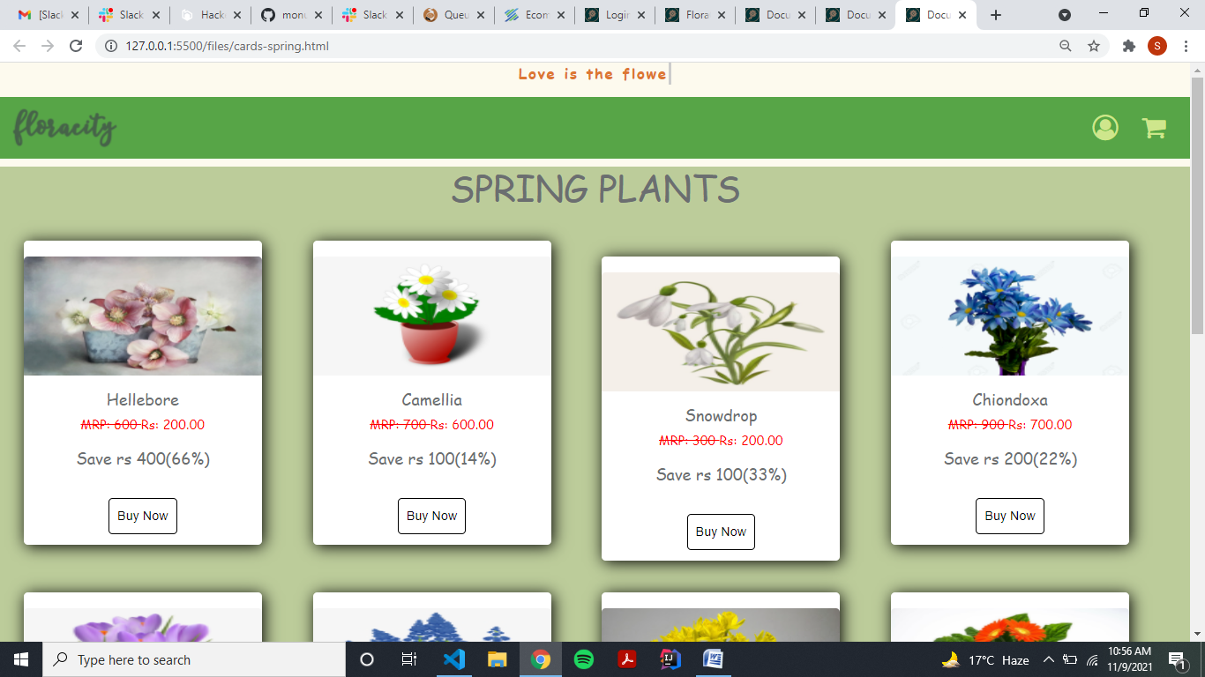

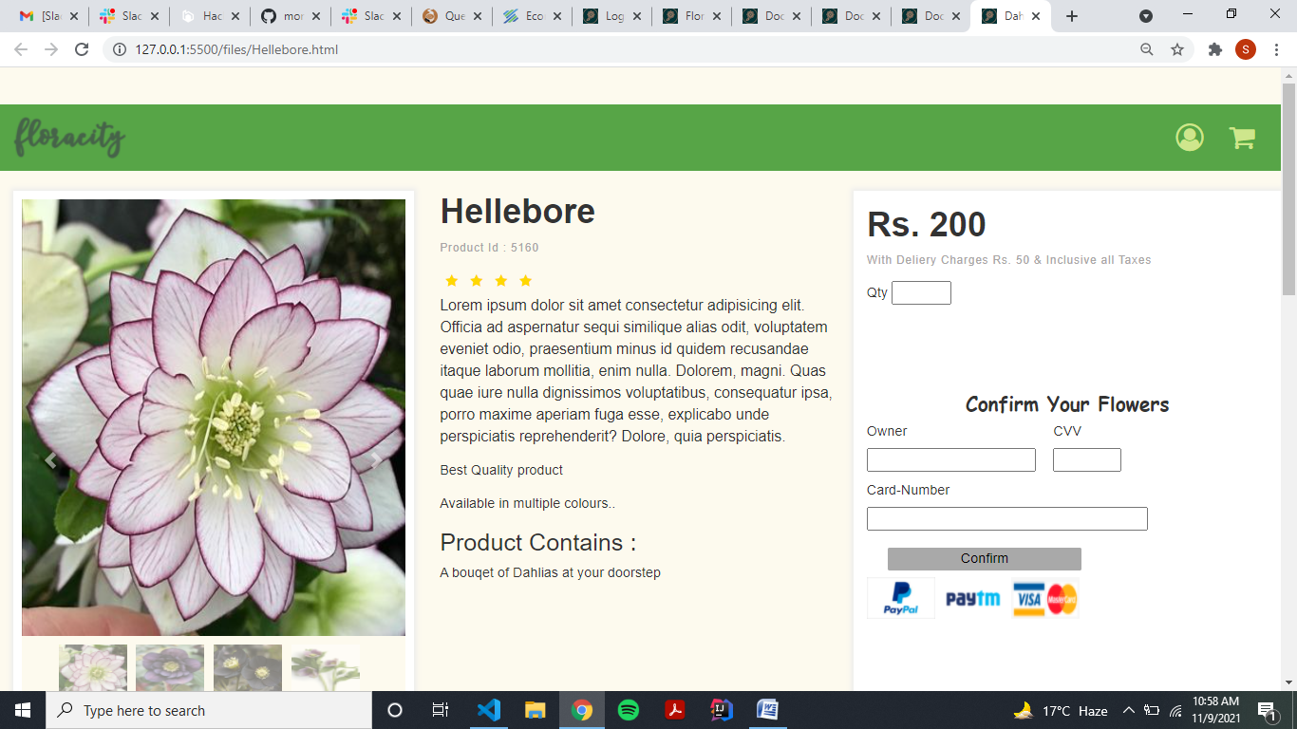

**CONCLUSION**

This project is only a humble venture to satisfy the needs in a shop. Several user friendly coding have also adopted. This package shall prove to be a powerful package in satisfying all the requirements of the organization. The objective of software planning is to provide a frame work that enables the manger to make reasonable estimates made within a limited time frame at the beginning of the software project and should be updated regularly as the project progresses.

This website provides a computerized version of shop manipulate system which will benefit the users as well as the visitor of the shop. It makes entire process online where users can search product, and buy various product. It also has a facility for common user by login into the system where user can login and can see status of ordered item as well request for items or give some suggestions. It provide the facility of admin’s login where admins can add various item, review users activity and also give occasional discount and also add info about different events for the customer.